* **How to Buy**

Using the CAD files to cut three stainless metal plates which is 1mm thick.

↓Standard Aluminum Profile

2 x 500mm 2 x 220mm (Ask the seller to cut)

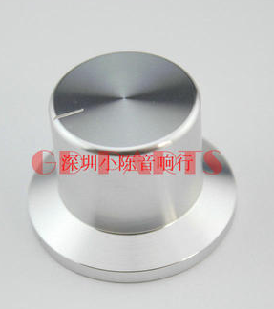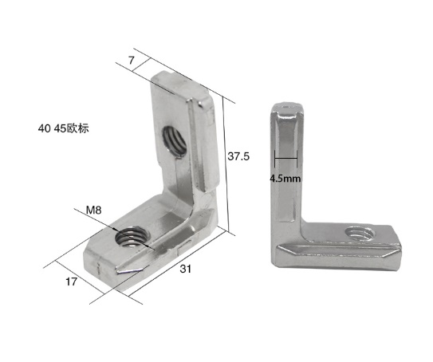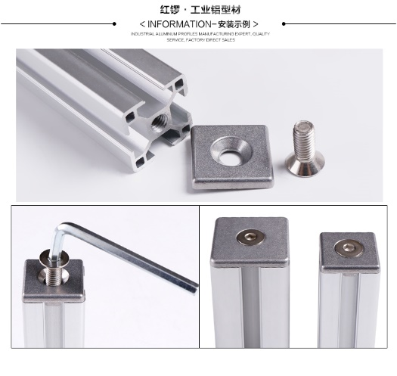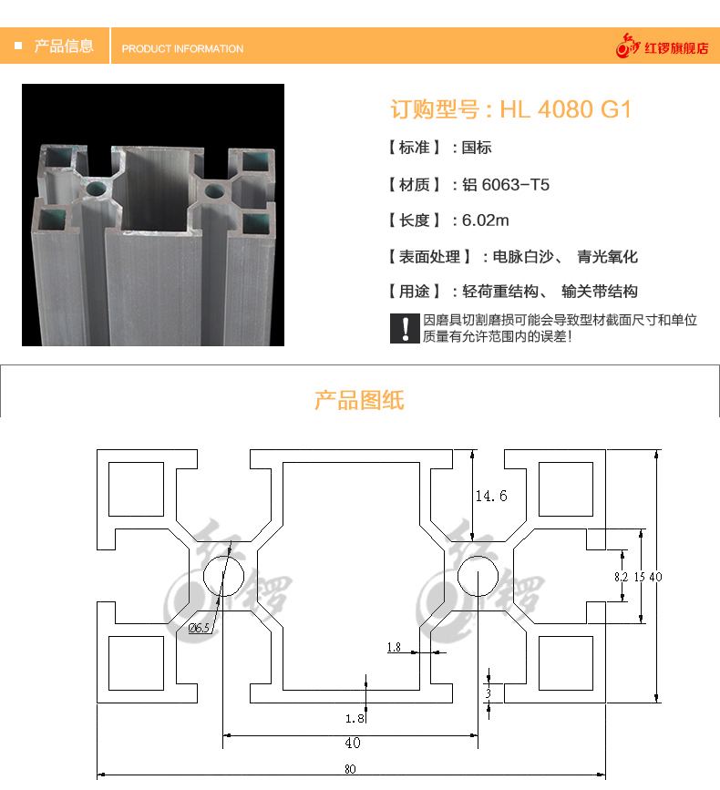

↑ Right angle connector x8↑tuner 38mm

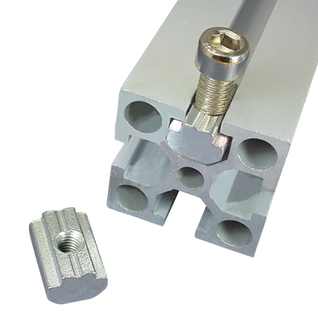←（OPTIONAL）End Cover

→M5 Screws and Nuts x16

Buy proper Buttons(69x69mm x4,44x44mm x1,50x33mm x2)

Omron switch D2MV-01-1C3 x7

Encoder E6B2-CWZ3E or similar x2 （Screws M3 x6）

Foots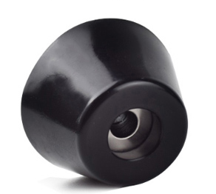like this

* 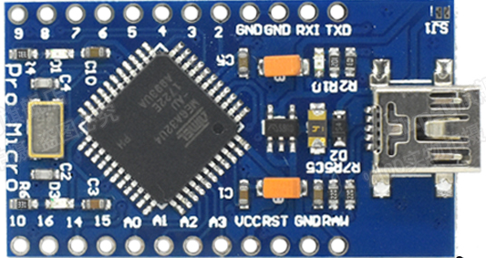**How to Build:**

GND

**…**

NO

GND

**Button**

NO

VCC GND

**Encoder2**

A B

VCC GND

**Encoder1**

A B